**MONGO DB TEST**

**NAME: MEGHNA MADHU**

**REG NO- 22BCE3379**

**Q1. Find the total revenue (price × quantity) for each item, sorted from highest to lowest**

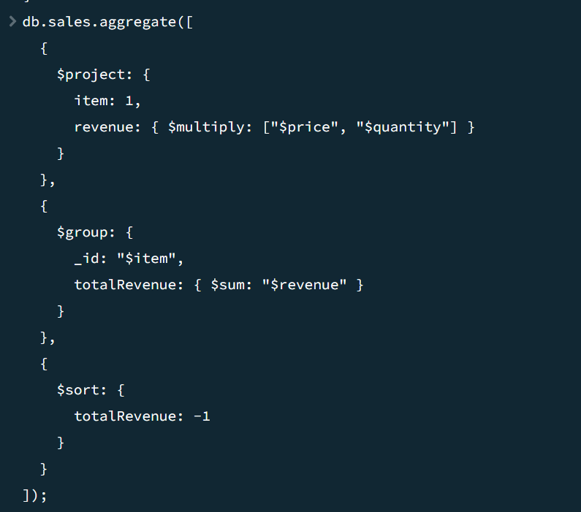

**Q2. Calculate the total quantity sold per month in 2022.**

**Q3. Find all items where price is greater than 10 and size is not 'Short'.**

**Q4. Get all Cappuccino sales with quantity between 10 and 20.**

**Q5. Query to find items where the item name starts with "A".**

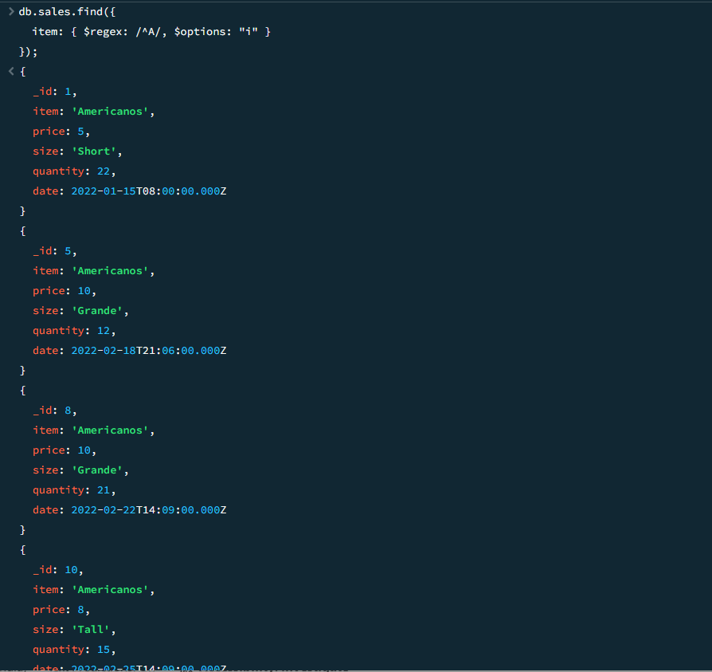

**Q6. Find all records that do not have the field size.**

**Q7. Find all sales that are either "Grande" or "Tall" but not "Americanos"**

**Q8. List all items sold in February 2022.**

**Q9. Find sales where the quantity is more than twice the price.**

**Q10. Find all sales where the price is greater than the average price of their respective size**.

**Q11. Filter sales where the total revenue is even and exceeds 100.**

**Q12. Find Sales Where the Day of Week Matches Quantity's Last Digit [Filter sales where the day of the week (0=Sunday, 1=Monday, etc.) matches the last digit of quantity].**

**Q13. Find Sales Where the Month is Prime and Quantity is Odd [Filter sales where the month (1-12) is a prime number (2,3,5,7,11) AND quantity is odd].**

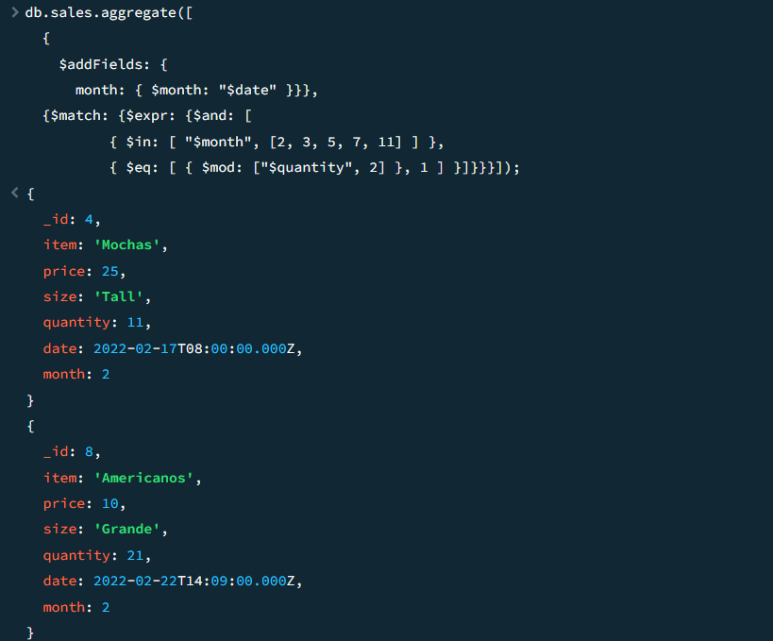

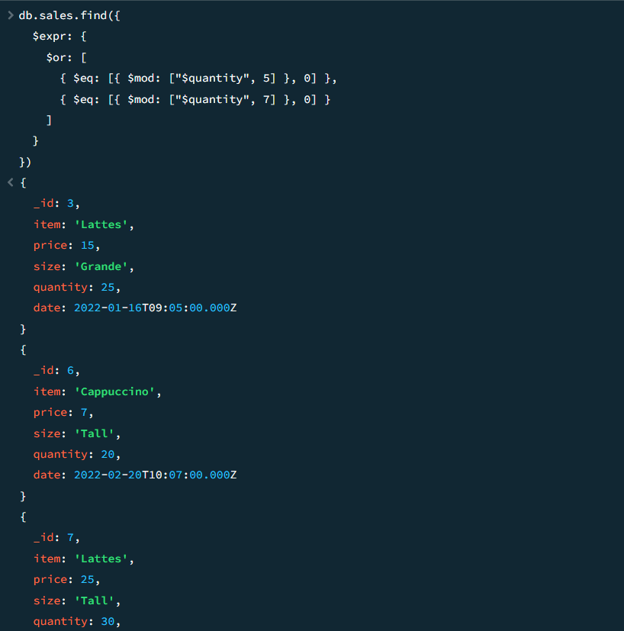**Q14. Find Sales with "Suspicious Quantities" (Divisible by 5 or 7) [Filter sales where quantity is divisible by 5 or 7]**

